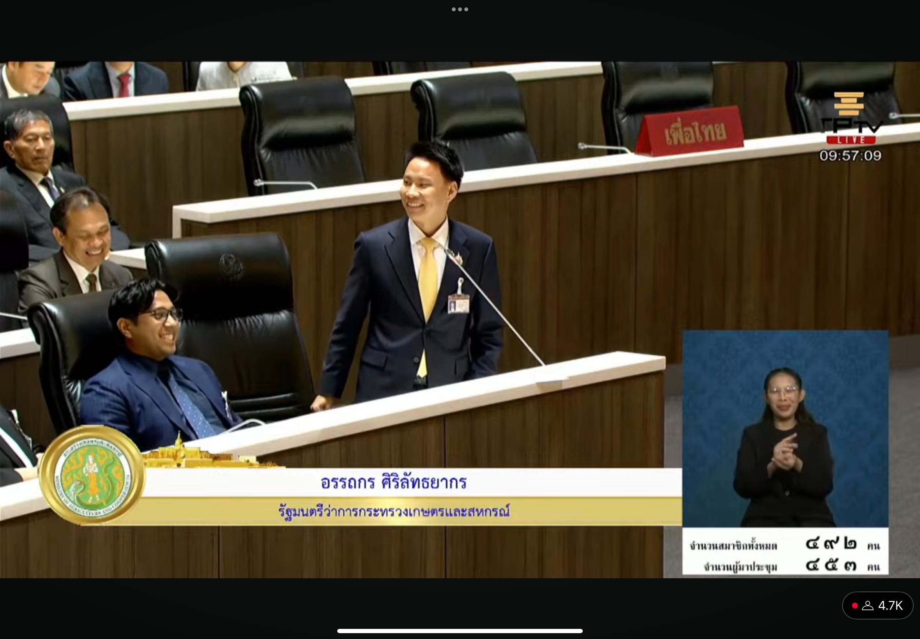

At this moment a member of parliament made a mistake pronouncing his speech, the parliament abrupt in laughter. Realistically, government and politicians are held to a higher standard, sometimes an unachievable standard. In moments like these it reminds watchers, citizens, that these people are also human. Also takes away from the image of parliament being intimidating, this encourages people to speak out.

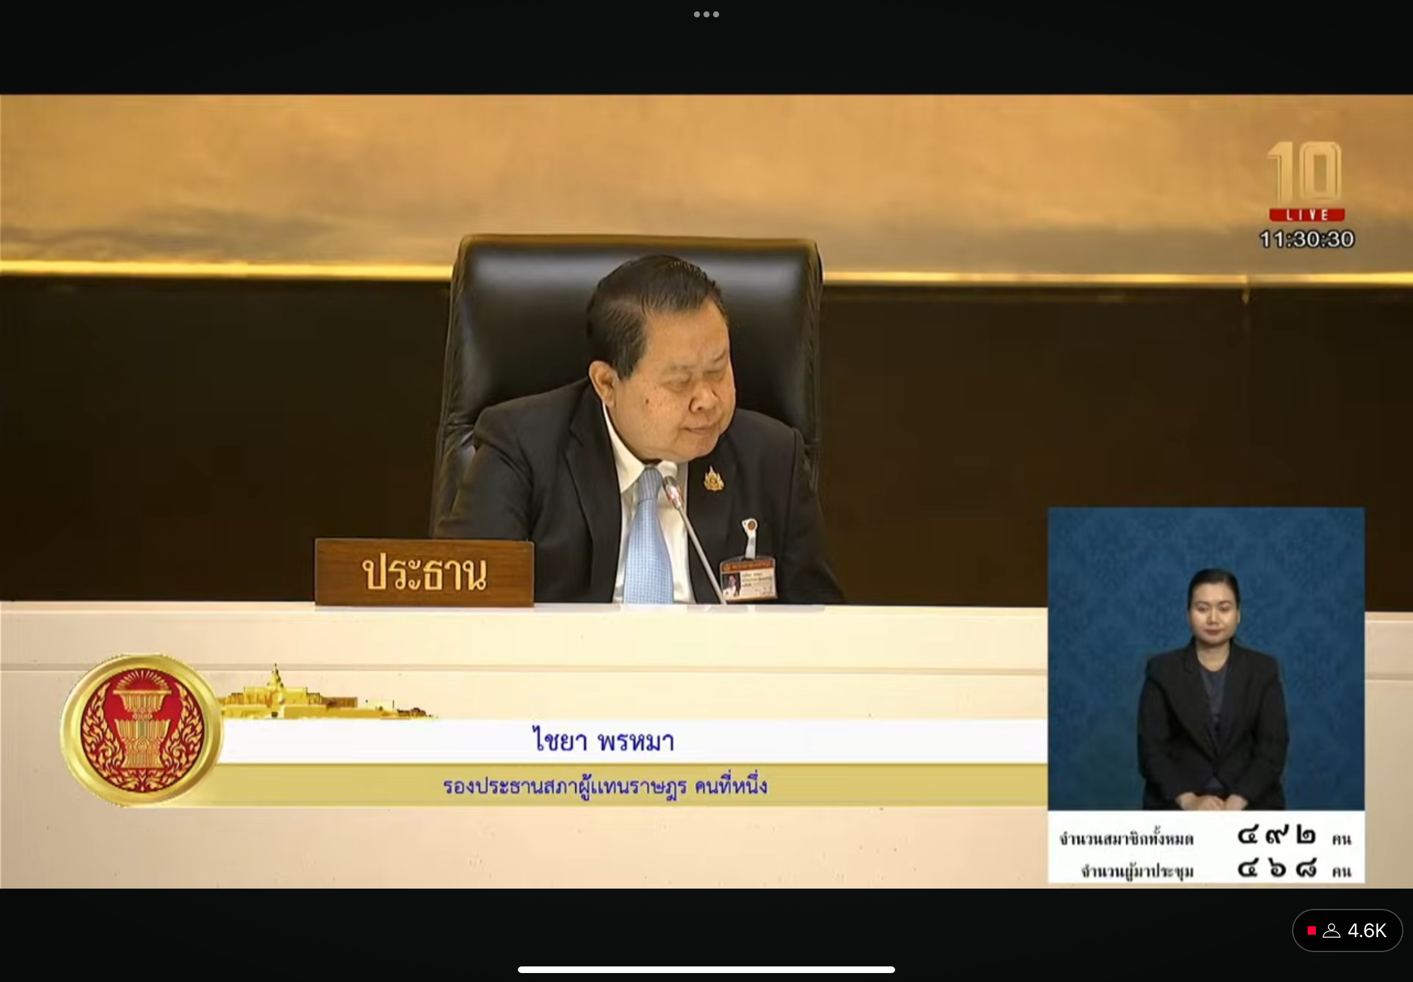

I don’t like the buzzing sound when the chairman asks the members of parliament to insert their identification card. I don’t like the loud buzzing.

I think that over the next few months Thai politics will settle for an interval of time, mainly from more attention grabbing matters such as Taksin’s promise to come back to Thailand, or people will be obsessed with how he will handle the Thai-Cambodia matter.